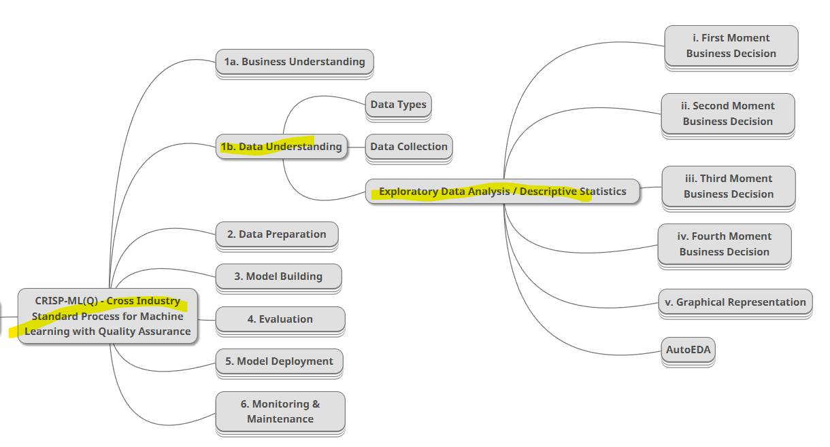

By doing **Exploratory data analysis** on data we can know **how clumsy is the data** is, it’ll be help full for data pre processing step. Doing exploratory analysis needs **knowledge on probability, probability distribution, inferential statistics, mathematical foundations.**

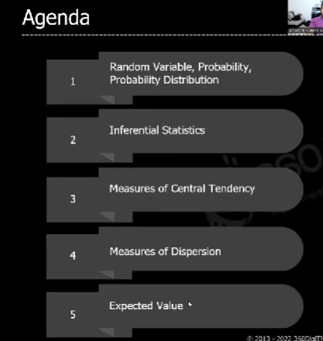

**PROBABILITY**

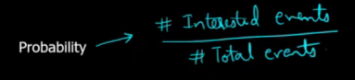

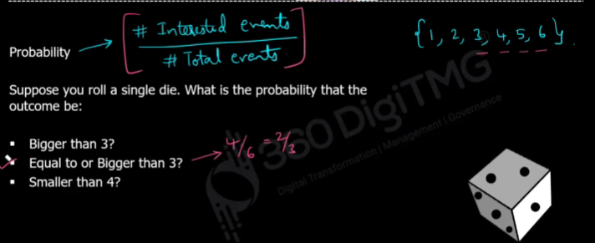

**Random variable**

It gives probability of uncertain events in numeric

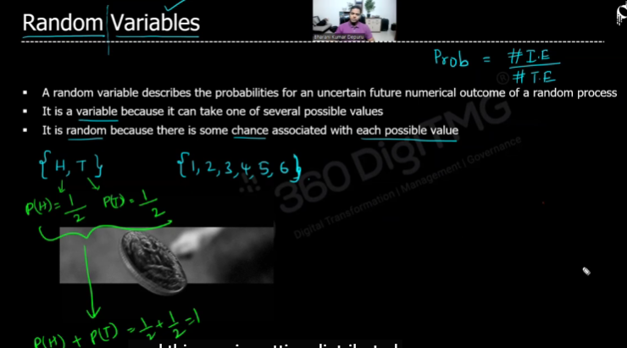

**Ex:**

Age is the random variable, that has uncertain values

